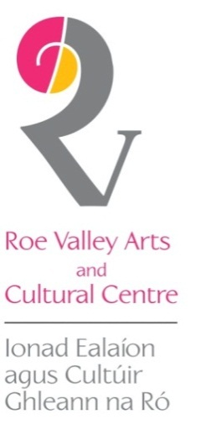
Snow
John Brown & James Hughes
8 Feb – 30 March 19

snow

master of ice on Esquiline Hill
paint for us
master of the black unadorned tree
stay with us
painter of an ordinary visitation
abide with us
painter of no piano on the Alps
play with us
master of morning or evening
light on snow
let us not need
any signature, tune
or time when we go

We are delighted to present this unique joint exhibition combining the atmospheric monochrome photographs of James Hughes with accompanying poems by John Brown.
On first study, it is easy to read that both are a celebration of wintertime, but further contemplation of the distinctive photographs and unsettlingly beautiful poems take you down a slightly different path… a stunning concoction of love, loss, loneliness and what it means to be human.
From Hughes’ striking images such as ‘Burgazada Delivery in the Snow’ to ‘Negotiating a Snowy Corner near the Blue Mosque’, where we encounter solitary figures in urban environments persevering in the harsh winter climate, to the interior remnants of lives lived and possibly forgotten in ‘Glenda’s Bed’ and ‘Mary Carey’s Hearth’, to a whisper of faith and longing in ‘One Legged Angel’ and ‘Grave Miniature’, we glimpse at the materiality and non-materiality of life, lives lived and lost.
The poetic resonance of Hughes’ work is sublimely matched by the gentle and potent poems created by Brown. Like the ephemeral nature of snow, from flake to ice to mud and water, Brown touches on memories and longings, of what has been and what is left, of presence and absence. Both create the perfect homage to winter, a time of contemplation and darkness and equally, of renewal and light.

SNOW READING & MUSIC EVENT:
Everyone is welcome to join James and John, Kyron Burke (pianist/singer), Aidan Mulholland (fiddler/guitarist), Hazilit Keers (guitarist) and Bill McCance (trumpet) for a unique musical and spoken word response to the exhibition in our O’Hampsey Studio on Friday 8 March at 7.30pm.
Free admission. All welcome

Currently based in Belfast, poet and curator John Brown was born in Co Derry. He studied English literature at Bristol University and Scottish literature at Edinburgh University, and has many literary magazines and publications as well as publishing numerous collections of his work.
Primarily based in County Antrim, James Hughes is a Northern Irish photographer and artist, whose photographic practice ranges from social documentary through commercial to fine art photography.
His first photographic experience was of a childhood spent using a box brownie (made by his mother when she worked for Kodak). James is self-taught, and influenced by late 20th century photography and literature, influences that he continues to link through his practice to-date.
James has an extensive background of research in photography (MA, MPhil). A celebrated photographer, with many exhibitions and awards, his work is represented internationally in museums and galleries, commercial work also has its place while he continues to pursue his personal career and passion through photography, art and poetry.
For further information, visit www.jameshughesfoto.com

SALE OF JAMES HUGHES PRINTS:
Limited edition of 10 each, £45.00 unframed. If you are interested in ordering a print, please note the title of work and speak to our reception team.

